How to Draw a Barn and Pond
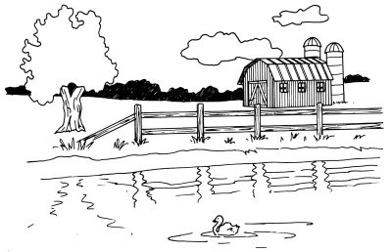
This farm life scene even includes an adorable duck, floating happily upon a pond. This landscape scene has a good variety of elements to draw -- water, building, plants, and animals.

In this section, we'll show you how to draw this barn and pond landscape. You can draw it freehand while looking at your computer monitor, or you can print out this page to get a closer look at each step.

Here, we'll show you an illustration of each step and then give you a description of how to draw it. Follow the red lines in each illustration to learn exactly what to draw in that step. The lines drawn in previous steps are shown in gray.

To start your barn and pond landscape drawing, lightly sketch a horizon line across the middle of the page.

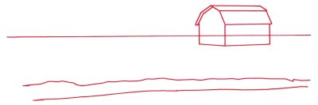
Step 1: Lightly sketch a horizon line across the middle of the page. Start the outline of the barn with a rectangle for the long side, then add the front as a rectangle that is open at the top. All the vertical lines should be parallel. Connect two of the vertical lines with two angled lines, as shown.

Use slanted rectangles for the roof. Begin the edge of the lake with a nearly straight line to show the edge of the water. Draw another, irregular line above it to show the limit of the sandy area.

To draw the barn and pond landscape, draw rectangles for windows and a door.

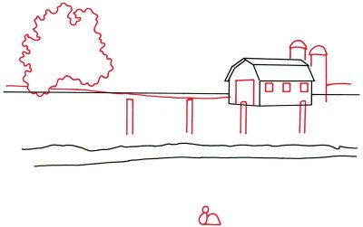
Step 2: Alter the horizon line so that it dips down in front of the barn and rises up behind it. Begin defining the barn by putting in rectangles for windows and a large door. Frame twin silo towers with tall rectangles, and cap them with half circles.

Start a tree to the left by sketching in the leafy top with a squiggly line. Draw fence posts with narrow open rectangles. Line up the tops of the posts with a ruler. Combine a small circle with an oval and a half circle to make the outline of a duck in the pond.

To draw the barn and pond scene, use V-shaped, horizontal, and vertical lines for boards on the barn door.

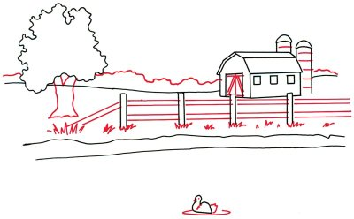
Step 3: Add a dot for the duck's eye, a tiny V-shaped figure for a beak, and a fluffy tail to make the duck look more real. Form a thin oval around it for a circular wave. Attach the rails between the posts by drawing horizontal and diagonal lines with the help of a ruler. Use a combination of V-shaped and horizontal and vertical lines for boards on the barn door.

Show sections in the silo with curved lines. Sketch the tree trunk using wavy lines. Use a squiggly line to form the top of the tree line in the background. Add tufts of grass along the edge of the pond with a series of jagged lines.

To draw the barn and pond landscape, give texture to the barn door with vertical lines.

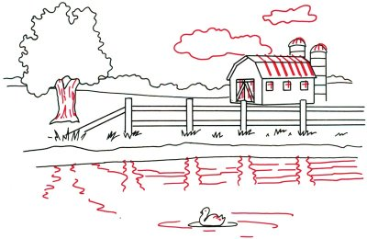
Step 4: Add clouds in the sky above the barn with irregular shapes. Give texture to the barn door with vertical lines. For the barn roof, use angled lines that follow the shape of the roof. Put crosses in the windows for windowpanes. Finish the top of the silo with four curved lines. Give texture to the tree trunk with broken lines. Show the reflections of the tree and fence on the water with wavy lines. Add a few feathers to the duck with tiny hooked lines.

Finish your barn and pond landscape with light shading to give texture to the fence.

Step 5: Darken the tree line in the background. Give the barn the look of wood siding with many closely spaced, parallel lines. Shade under the barn roof with crisscross lines. Finish with light shading to give texture to the fence.

Your landscape drawing is finished!

